How to use Effectivity Macro 2.0

# Selecting and Formatting Effectivity

1. Open the “Effectivity Macro” program

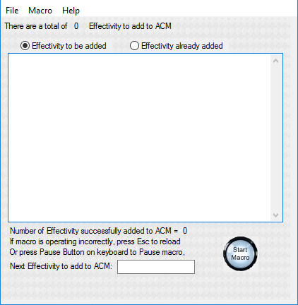

1. In the Pubtool Effectivity screen, select the “Affected” effectivity that is needed. Make sure to include all the information as shown in the examples shown below.

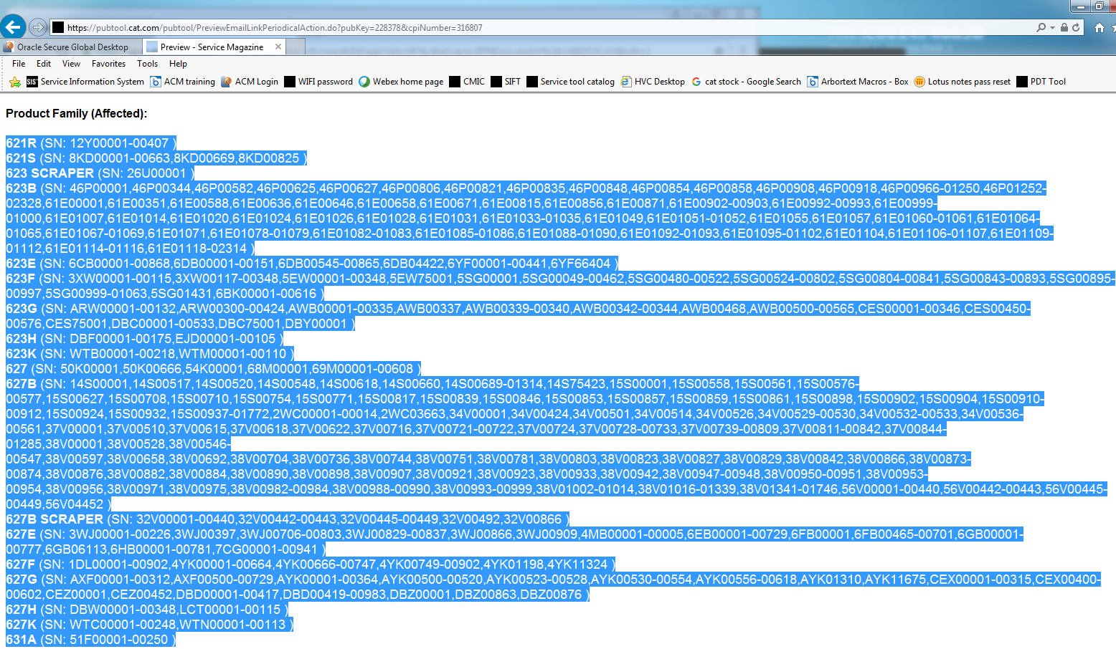

Example 1

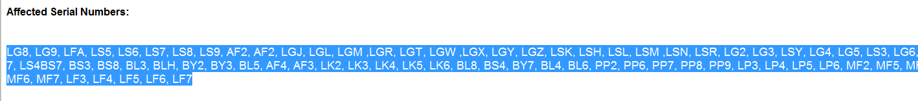

Example 2



Example 3

* 1. With the Effectivity Macro program open, Press Ctrl + 1 in the PDT tool screen, the macro will copy all the selected text and bring up the below window.

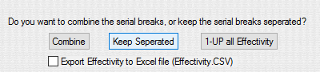

* 1. With the Effectivity Macro program open, copy and paste the PDT tool effectivity into the Effectivity macro window and press the Start Macro button as shown below. The Window above will display asking the user how to format the effectivity.

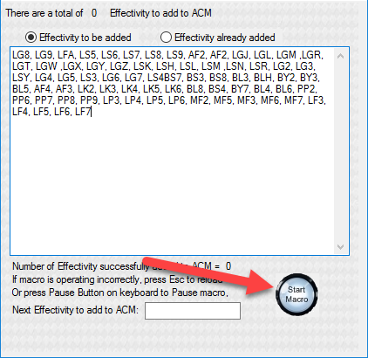

1. The window above will appear asking if you want to keep all the effectivity breaks, to combine them to one single effectivity per prefix. (The lowest and the highest # per prefix), or to make the effectivity 1-up. The macro will then automatically format and paste/update the text into the Effectivity Macro window.

# Effectivity Screen Setup After Formatting

1. The below message box will then appear. Follow the directions of the message box BEFORE pressing the OK button.

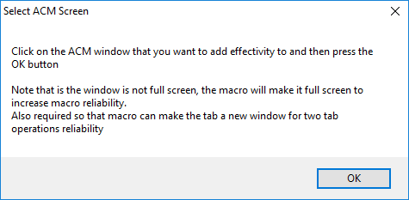

## Below is for Single Tab Operation / Continuation of Dual Tab Operation

1. After following the directions of the message box. The macro will maximize the ACM effectivity screen. Maximizing the screen helps with the reliability of the macro. See image below.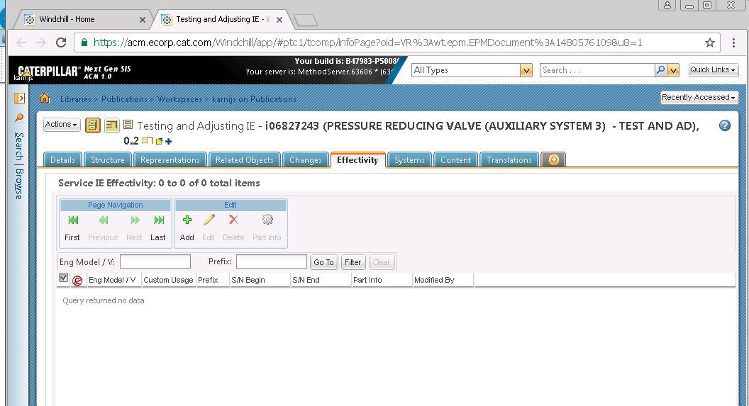

**FOR DUAL TAB OPERATION ONLY:**

1. The macro will open a new window in Oracle and go to the IE page. This action is to help setup for a reliable dual tab operation.
2. A tooltip will be shown under the mouse cursor giving instructions. This tooltip is shown in the image below



1. Hold down the Shift key and then click on the “Effectivity” Tab in the effectivity Screen and let go of the Shift key. See image below.

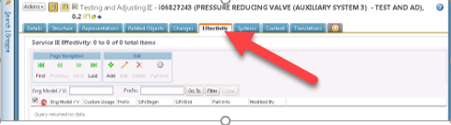

**CONTINUE WITH SINGLE OR DUAL TAB OPERATION:**

1. A tooltip will be shown under the mouse cursor giving instructions. This tooltip is shown in the image below
2. 
3. Hold down the Shift key and then click on the “Add’ button in the effectivity Screen and let go of the Shift key. See image below.
4. 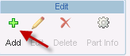
5. After that action is performed, a new tooltip will be shown under the mouse cursor a few seconds later as shown below. Hold Down the Shift key and then mouse button click on the “Prefix edit box and let go of the Shift key.
6. 
7. 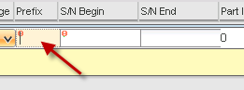
8. After that action is performed, a new tooltip will be shown under the mouse cursor a few seconds later. This tooltip is shown in the below image. Hold down the Shift key and then mouse button click on the “Apply” Button. These actions allow the macro to find where those buttons are located on your screen for later use.
9. 
10. 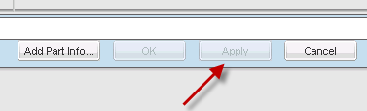

**FOR DUAL TAB OPERATION ONLY:**

1. Macro will create a duplicate tab in the window and auto click on the effectivity tab and the add button.

**CONTINUE WITH SINGLE OR DUAL TAB OPERATION:**

1. Soon afterwards, the macro will automatically begin to enter the information from the Effectivity Macro window and into the ACM screen. During this process, if you move the mouse or try to type, the macro will automatically pause at the beginning of a new cycle. The macro will wait for 5 seconds of no activity before it resumes. DO NOT lock the computer it as it will mess up the macro. If you need to pause the macro, you can press the Pause or Insert key on the keyboard, and the macro will pause. You can resume the macro by pressing the pause button on the Effectivity Macro window, or by pressing the pause or insert button on the keyboard. After the user defined (from options screen) effectivity number additions to ACM, the macro will refresh the ACM screen and click on the Add button to continue entering effectivity numbers. This prevents the issue with ACM when many effectivity numbers are added and the ACM server slows down.

# Operation of Automatic Issue Detection

## More than one Engineering/Sales Model

If more than one engineering/sales model is present, the macro will detect this and automatically place the effectivity that is detected to the end of the effectivity list. The macro will also take any prefixes that match the effectivity that triggered the detection and place them at the end of the list. When the macro reaches the end of the list, the Multiple Effectivity mode will be enables and the macro will display a flashing window to notify the user that the effectivity needs user input. NOTE: Dual tab operation will be deactivated at this point.

Once the User selects the correct engineering/sales model, the macro will auto detect the input and click on the apply button for the user. Then automatically move the mouse to the area of the engineering/sales model drop down list. The macro will log the issue when it logs the effectivity to the Effectivity Already Added list

Select the engineering model according to your Pubtool serial list. You may have to select the Sales model first to pick an engineering model.



# Effectivity Does Not Exist

If the effectivity does not exist in ACM, the macro will auto detect this and will clear the edit fields of the ACM screen, log the effectivity and skip/log any matching prefixes to the one that triggered the issue. No user input will be needed. Once the macro is done, please contact the correct individual to have the missing effectivity added into ACM so the effectivity can be added to the media.

Macro Window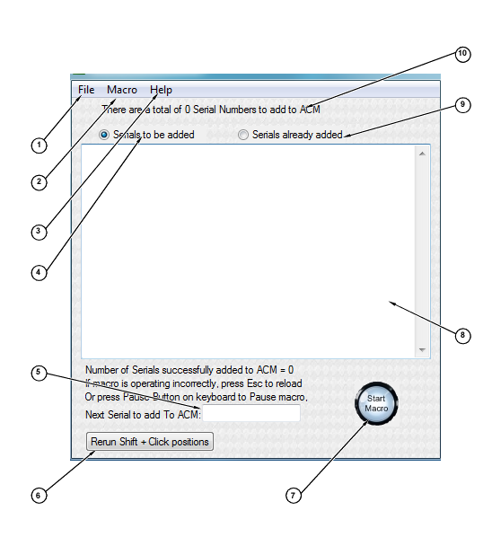

1: File menu

Check for update -> checks for an update of the macro

Quit -> Quits macro

2: Macro menu

Run -> Starts the macro

Pause / Unpause -> Stops the macro in mid process

Stop Macro -> Stops the macro and ends the current session

Reload Macro -> Reloads the program to start a new session

3: Help menu

How to use -> Brings up this PDF

About -> Displays the contact information for bugs and enhancement requests

4: Once selected, box (8) will display the serials that were formatted and ready to be entered into ACM

5: Shows the next serial that will be added to ACM.

6: Button resets the Shift-Click procedure.

7: Button to show program status.

8 Display box that allows user to view, edit or copy content

9: Once selected, box (8) will display the serials there were entered into ACM, as well as the logged bad serials.

10: Displays the amount of serial prefixes that were formatted.